2.1 distribution pattern of request and efficiency

We plotted two sets of heatmap, one by month and weekday, one by hour and weekday. Then within each set of heatmap, we compared the request number they received, and the request handling efficiency they display.

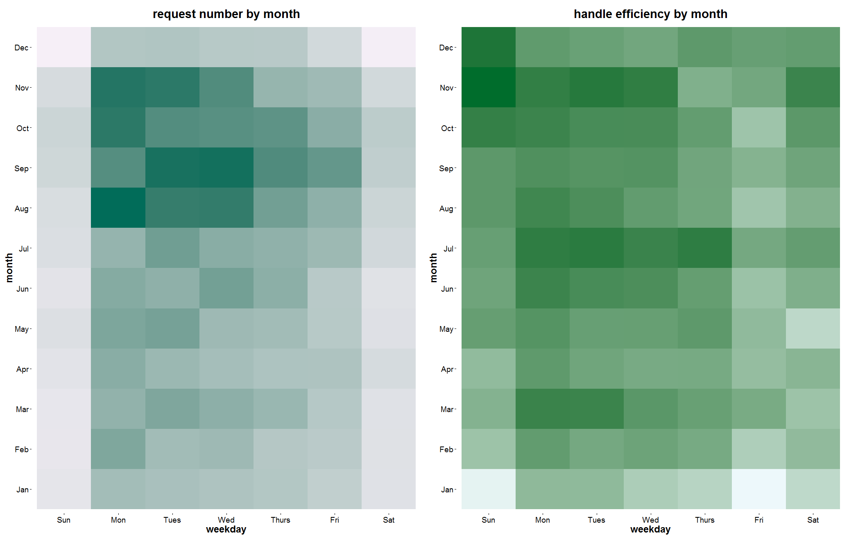

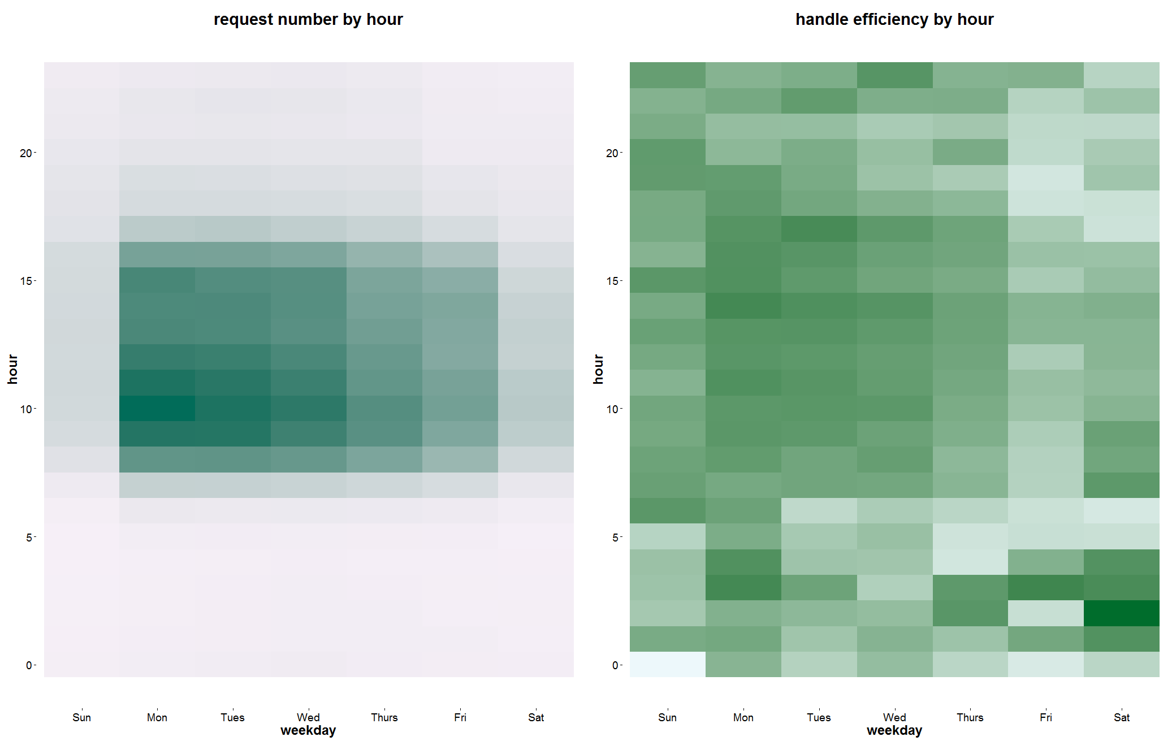

* Pattern found:
* More 311 requests are made from August to November, Monday to Wednesday, and in office hour (8 to 17).
* On the contrary, they are more efficient in handling request in March, July, and November, from Sunday to Wednesday, especially from 0-5 on Friday and Saturday.
* Insights:
* People tend to make more request in the last season each year, and the efficiency in handling request need to be improved generally.
* For now, we display good consistency in receiving and handling request in each week, because high request number and high efficiency all appear from Monday to Wednesday.
* Department tend to be more efficient when they work overtime, because 0-5 on Fridays and Saturdays are showing highest efficiency.

2.2 Efficiency in handling

2.2.1 Time Series

We did a time series to show how, by time, request is received in number, and is handled, with handle time we defined as updated data minus create data. Then we split the handling time down into service time and close time, so that we develop a handling funnel to show how request is handled by how long it takes from create to serve, and from serve to close. Hereby, we define service time as service data minus create data, and close time as close data minus service date.

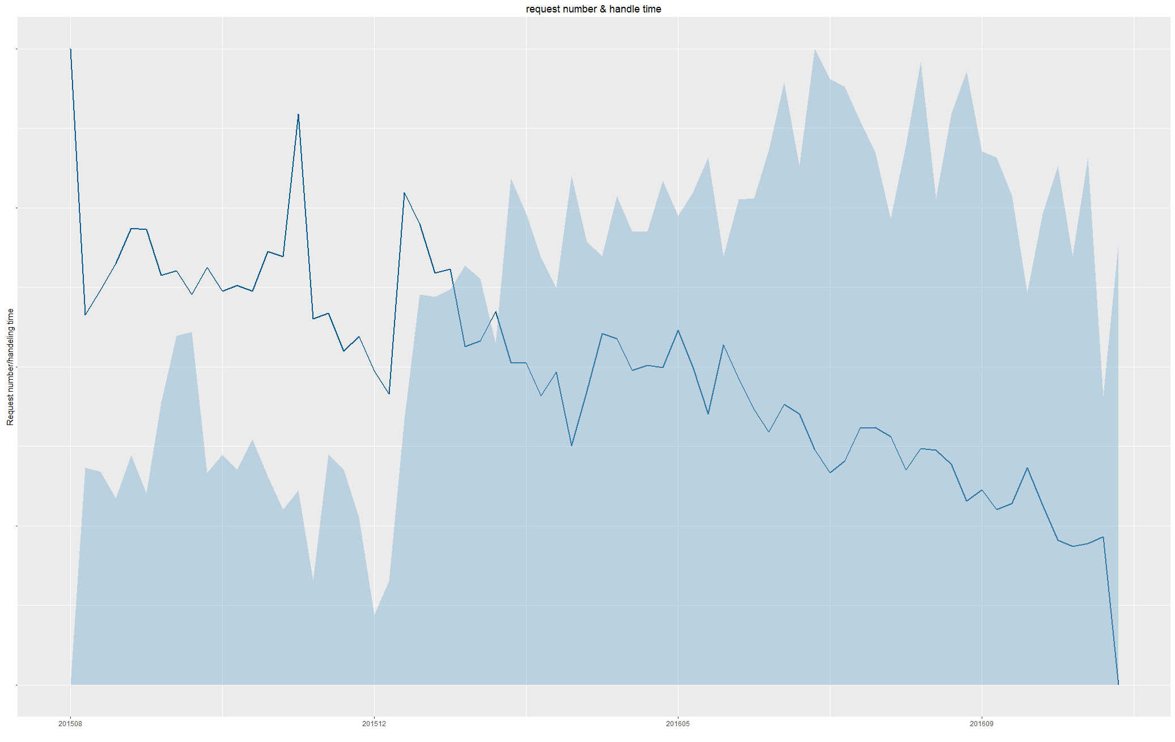

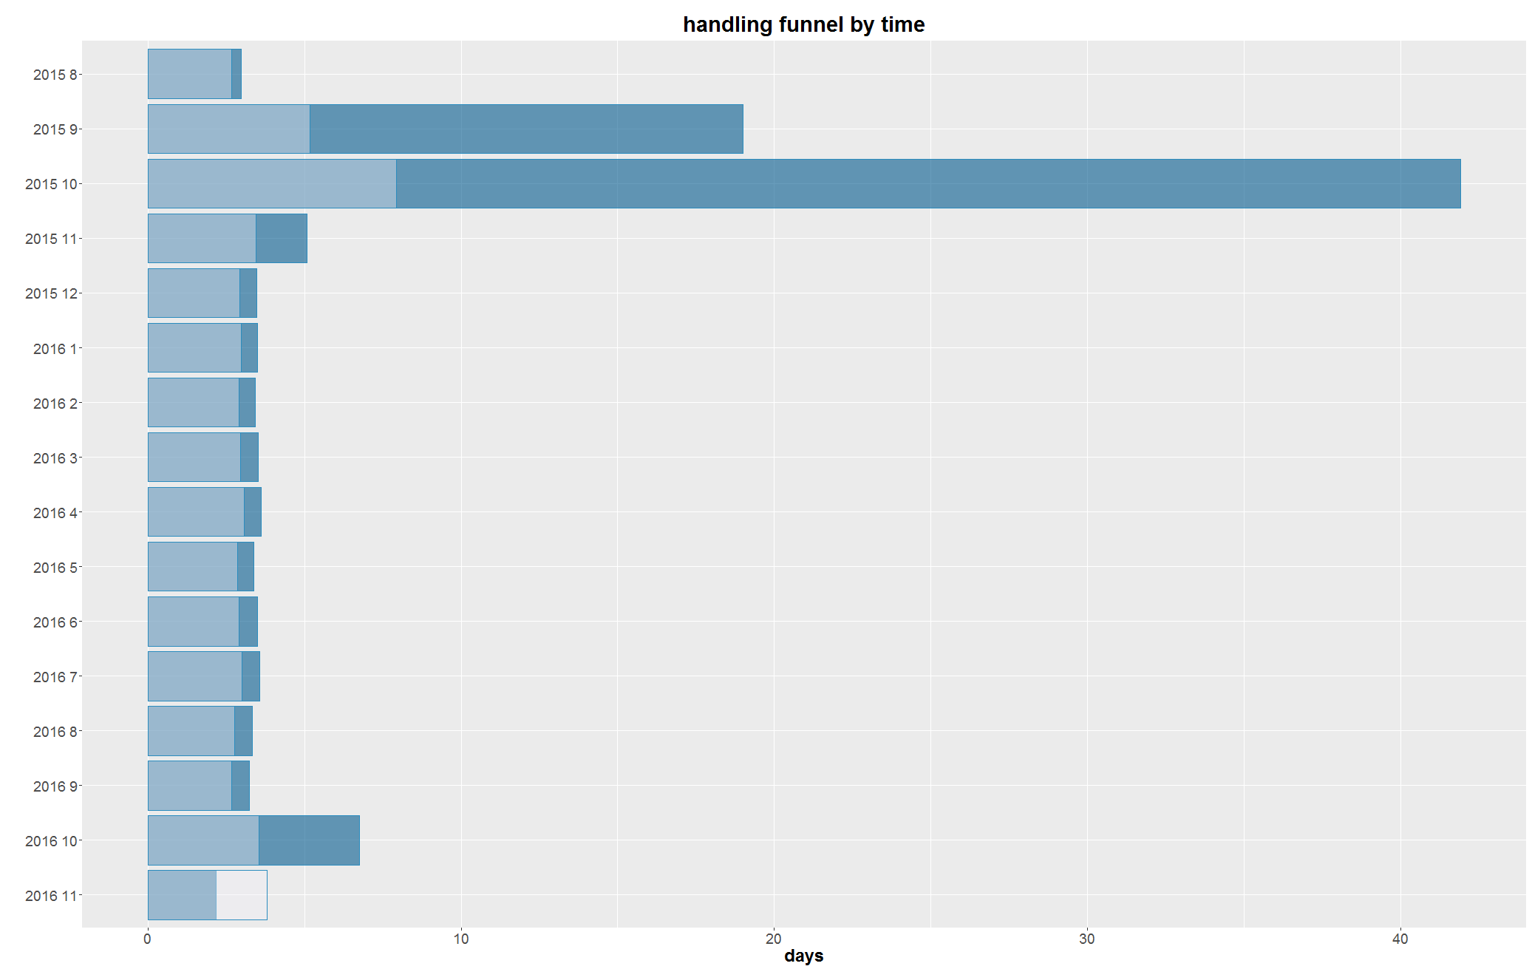

* Insights:
* By time, more requests are received, which means more people using 311 service. And more efficient request is handled, also departments are displaying more stable capability in handling request, because the fluctuation in handling time line is going down by time. So generally, great efficiency is achieved.
* There is one dramatic drop in request number in Dec 2015, then it rose again in Jan 2016, could find out the reason behind that abnormality, which will help us better serve citizens in the future.
* The handling funnel by time point out there is a disturbance in handling request in Sep and Oct 2015, which may be due to reorganization, because after that, great and steady efficient was generally displayed.
* Should probably mind the low efficiency in Oct 2016 and find out the reason.

2.2.2 request number and handle efficiency break down

* Pattern in request type
* As for most frequent request, bulky items and graffiti removal, great efficiency have been achieved consistently.
* Over time, improvements are made. Those at first cost more time to handle, dead animal removal, homeless, and others, their handling efficiency has been enhanced over time. Also, for streetlight issues, more stable efficiency is achieved over time in handling these requests.
* Requests with increasing frequency over time, such as water waste report and graffiti removal, should be payed attention.

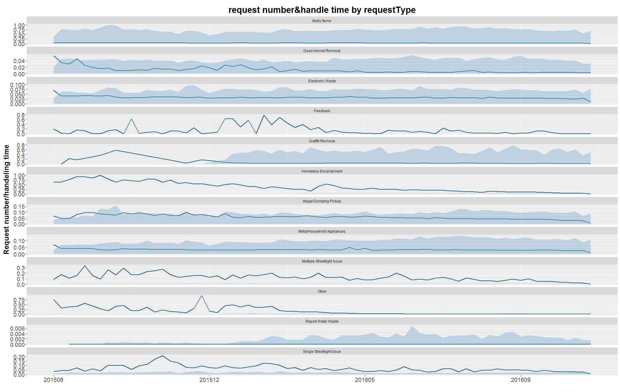

* Pattern in owner
* BOS and OSB are star departments as they handle large amounts of requests with high efficiency.
* BSS is the least efficient one, because it only handles graffiti removal well, so we could either improve its comprehensive handling capability, or specialize it on graffiti request.
* LAWP is receiving more and more request over time, and also showing good efficiency.
* BOE has only received 3 request in 18 months, so we could consider remove it from owner list, because it's not cost effective.

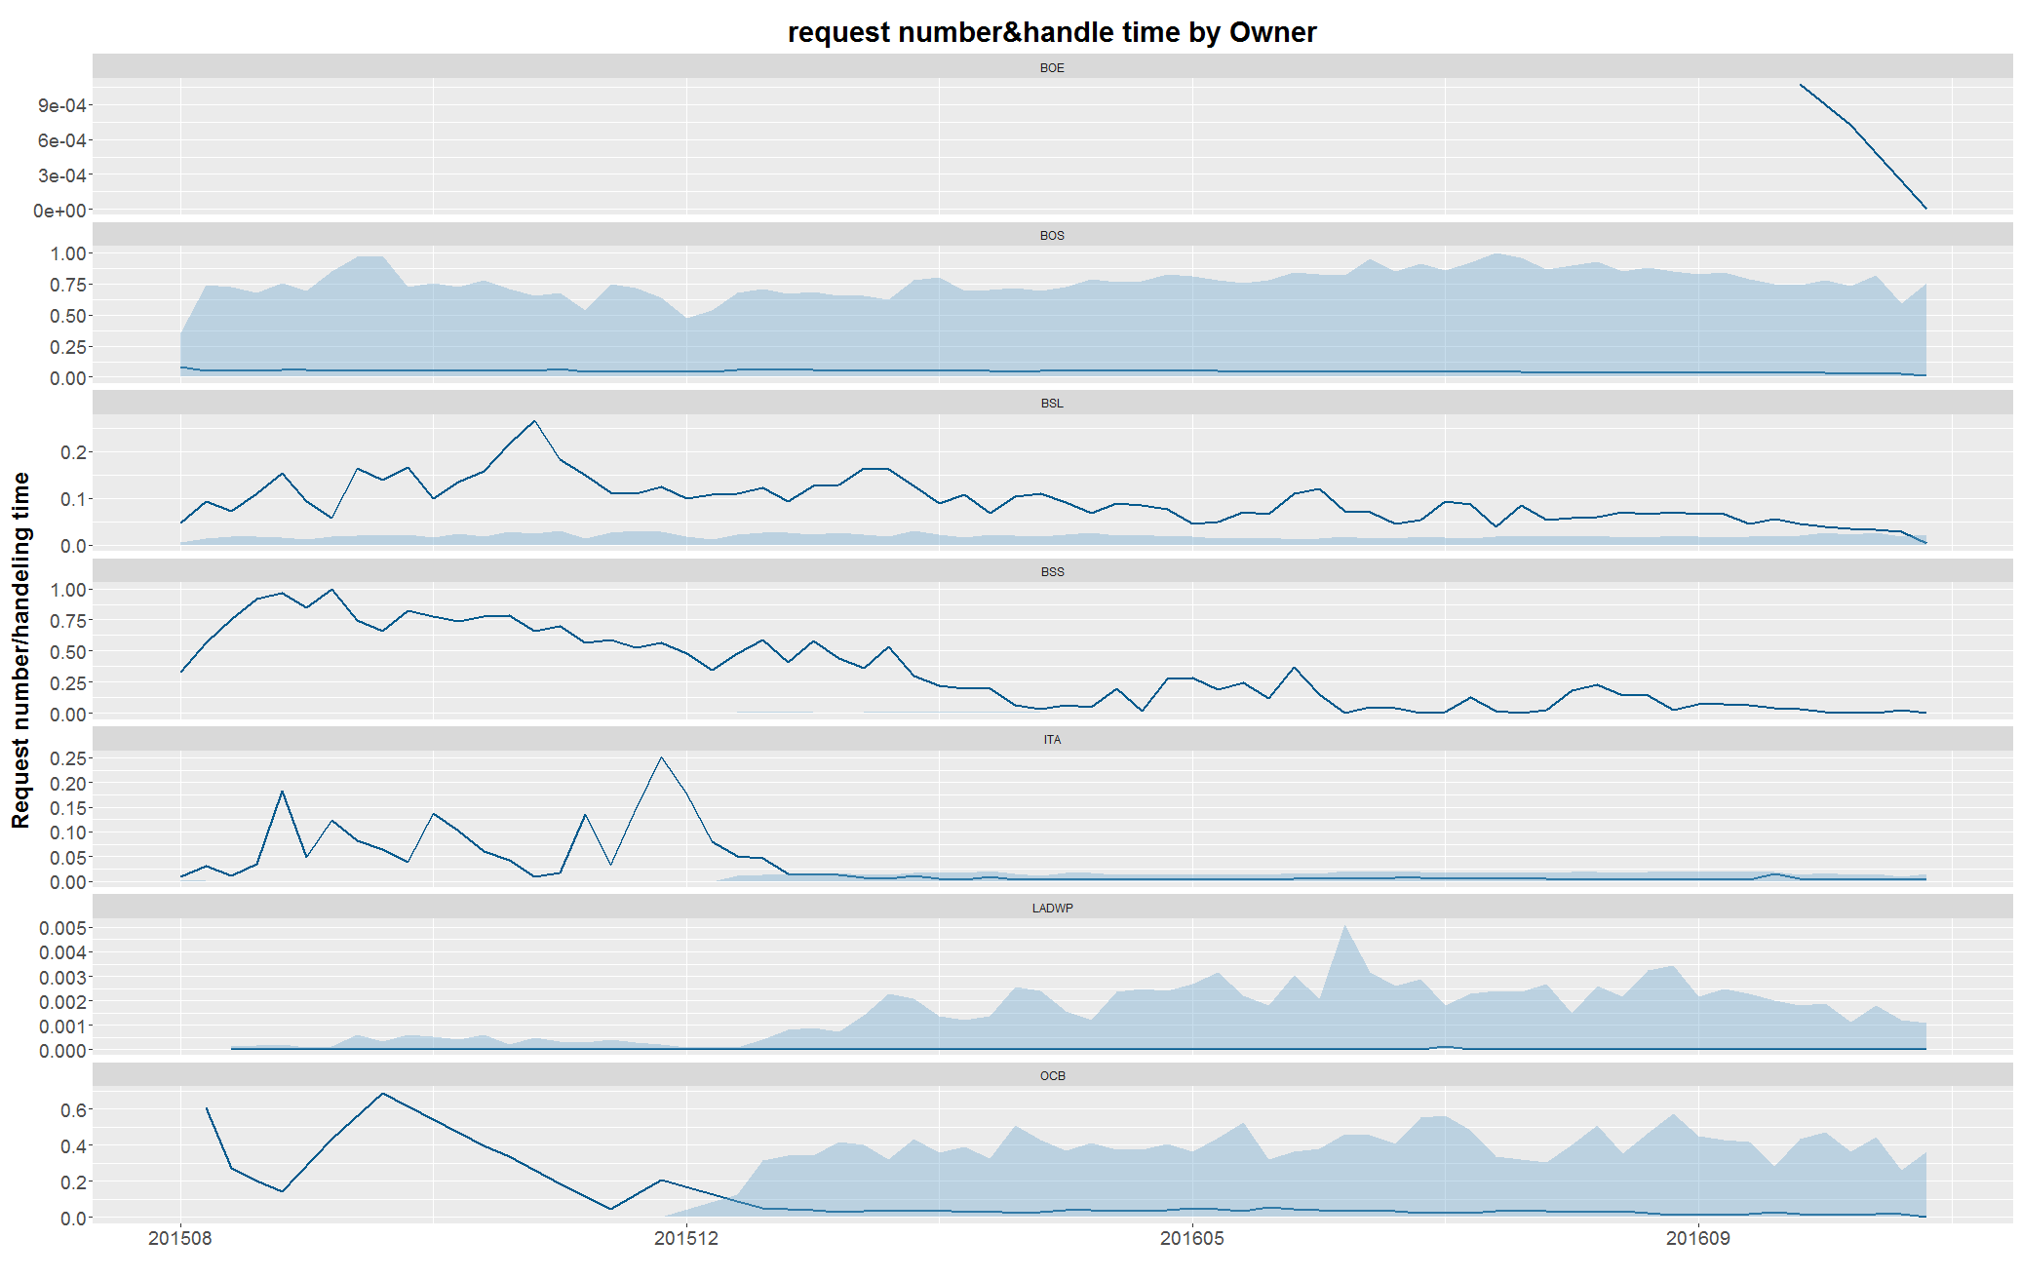

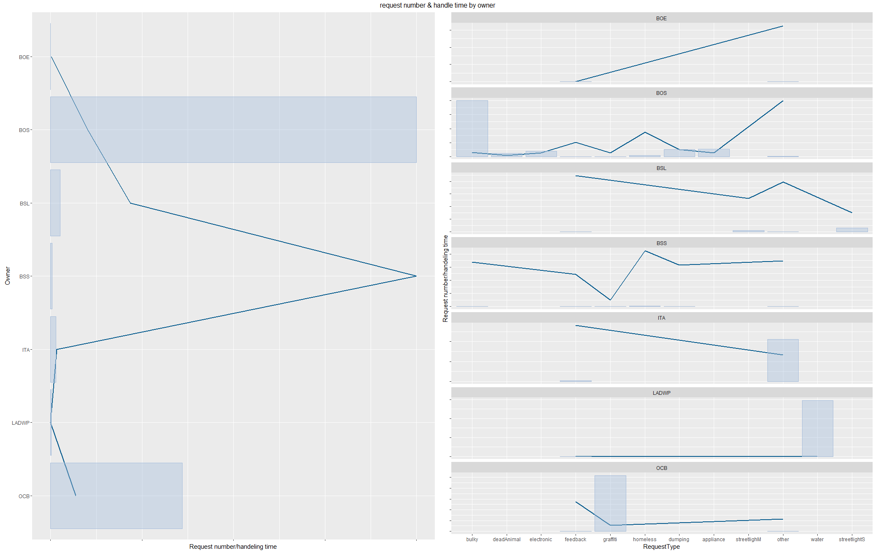

2.3 matching right department to request

If we break down request frequency and handling efficient by request type, owner, and assigned department, we could match right department for different request type, so that we achieve higher efficiency in handling, because data shows us each department's specialties.

* Insights:
* For those requests we have trouble handling, which are homeless, feedback, and streetlight issues, we could identify right departments to process them by owner break down, so we give feedback to BOE, homeless to BOS, and streetlight to BSL.

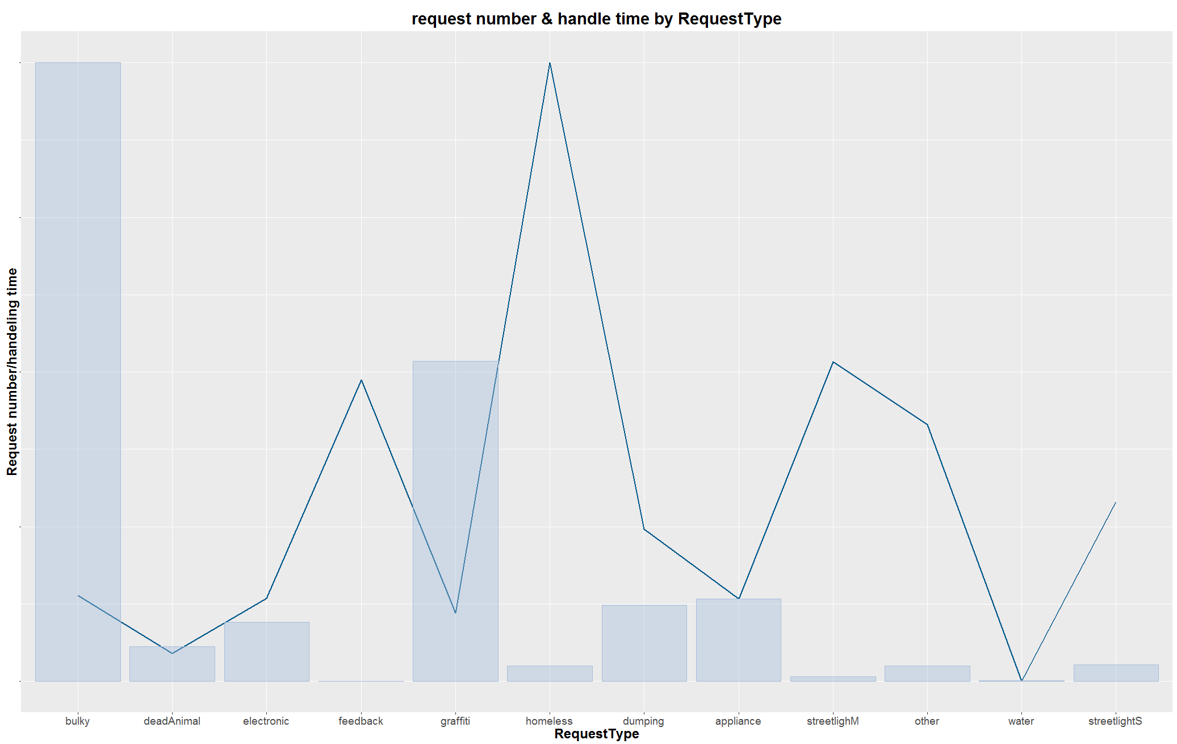

* Also, graphs help us identify each department's specialties, such as BSS is good at graffiti removal, then LADWP is specialized in water waste report.

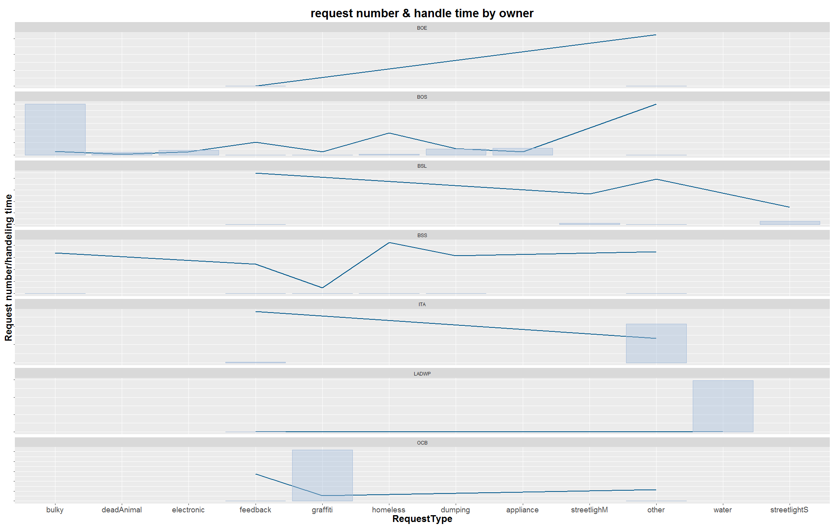

* As to assigned department, those on the right-hand side in the graph displays good capability.

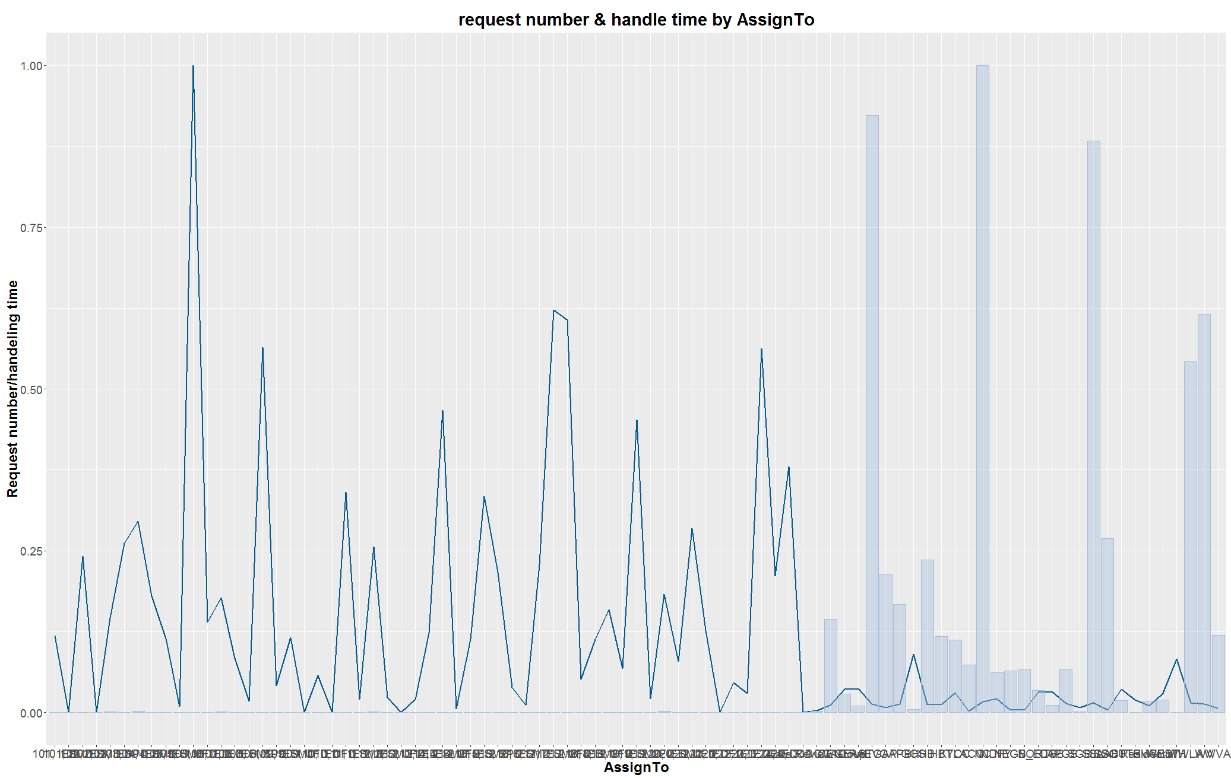

3.1 general pattern and abnormality

We used ACS 2014 5-year census data to get the population and median income by zip code, and plotted two contour map as the background map for plotting 311 data.

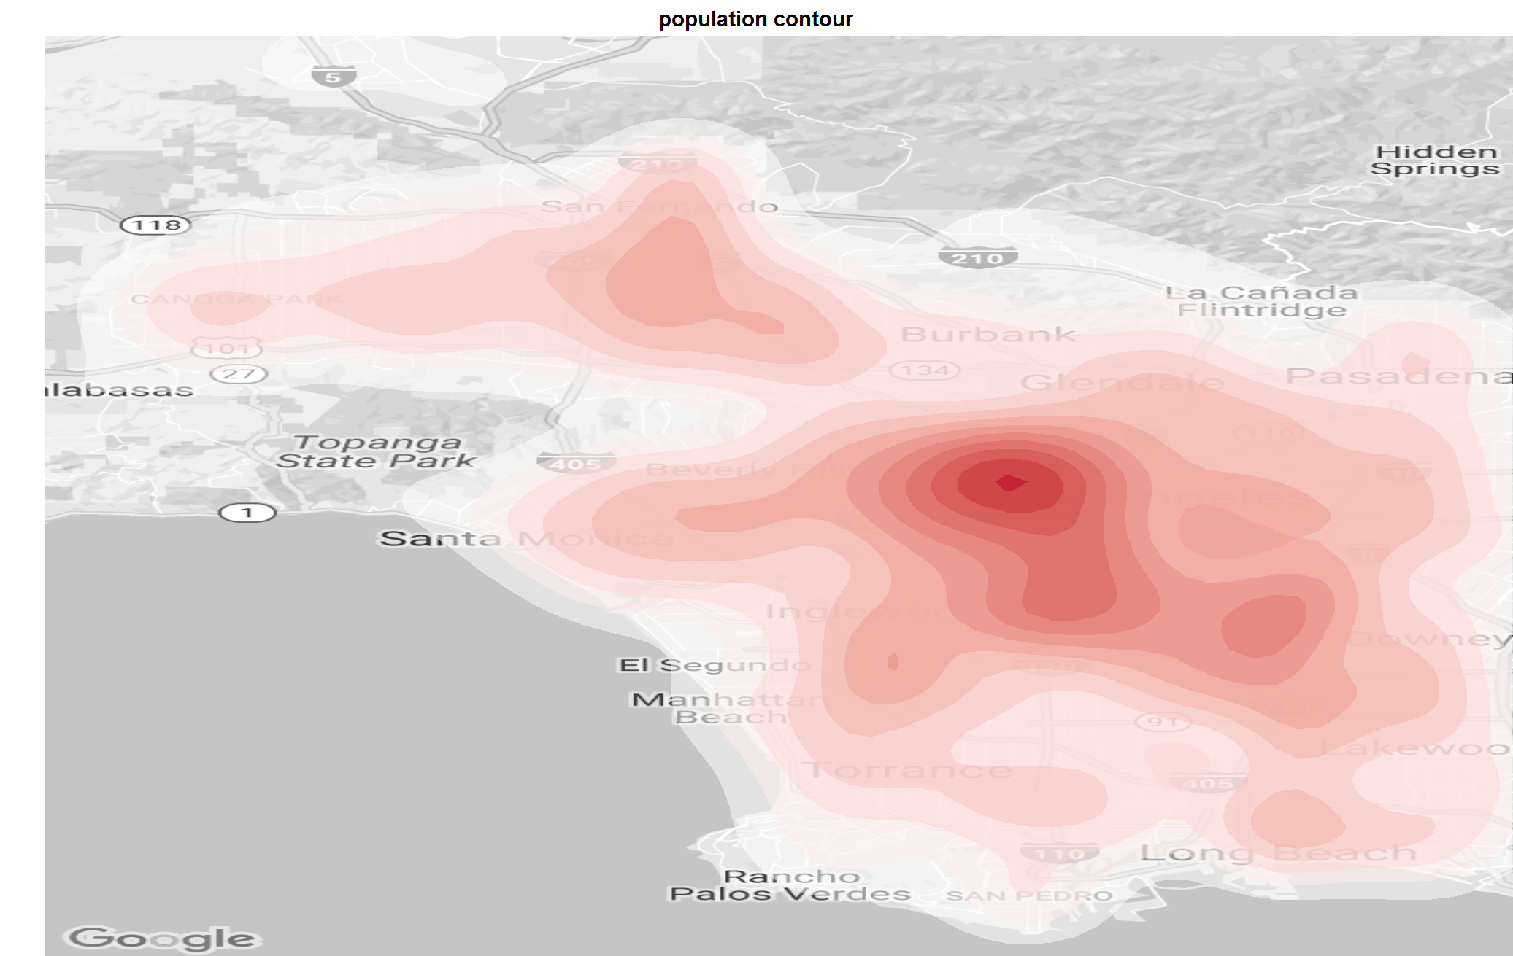

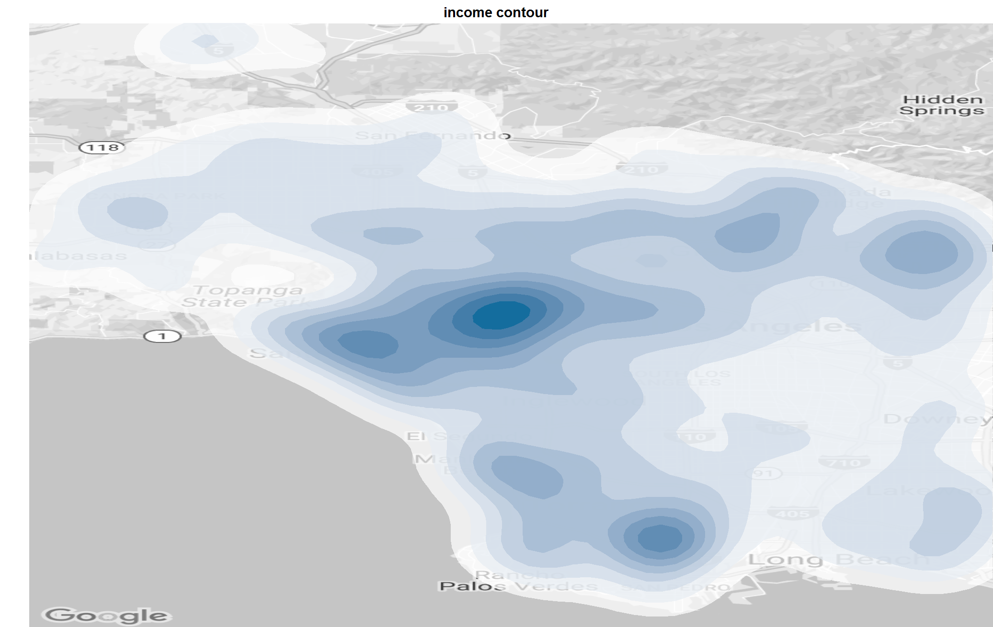

Then we plotted 311 data on population and income map to find out the general pattern of data geometry, and 311 data's relationship with population and income.

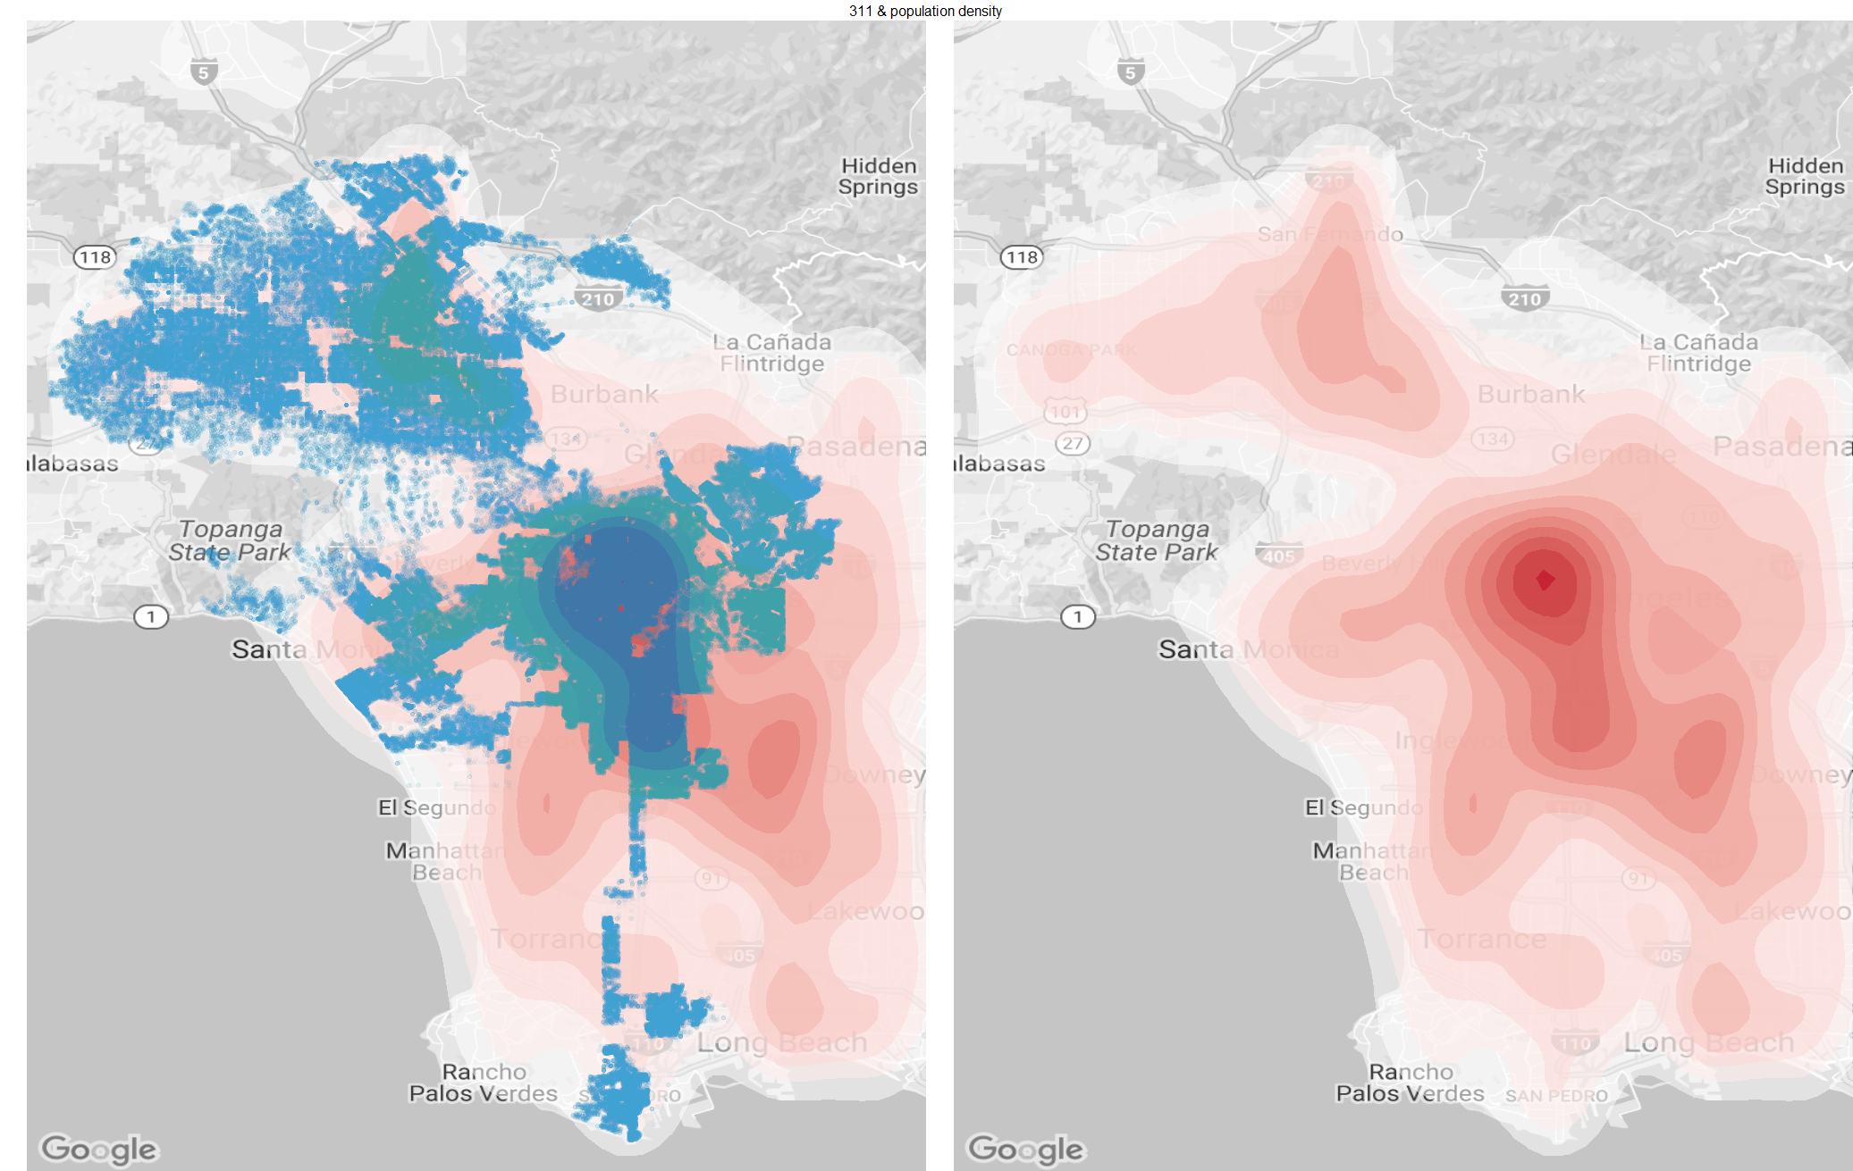

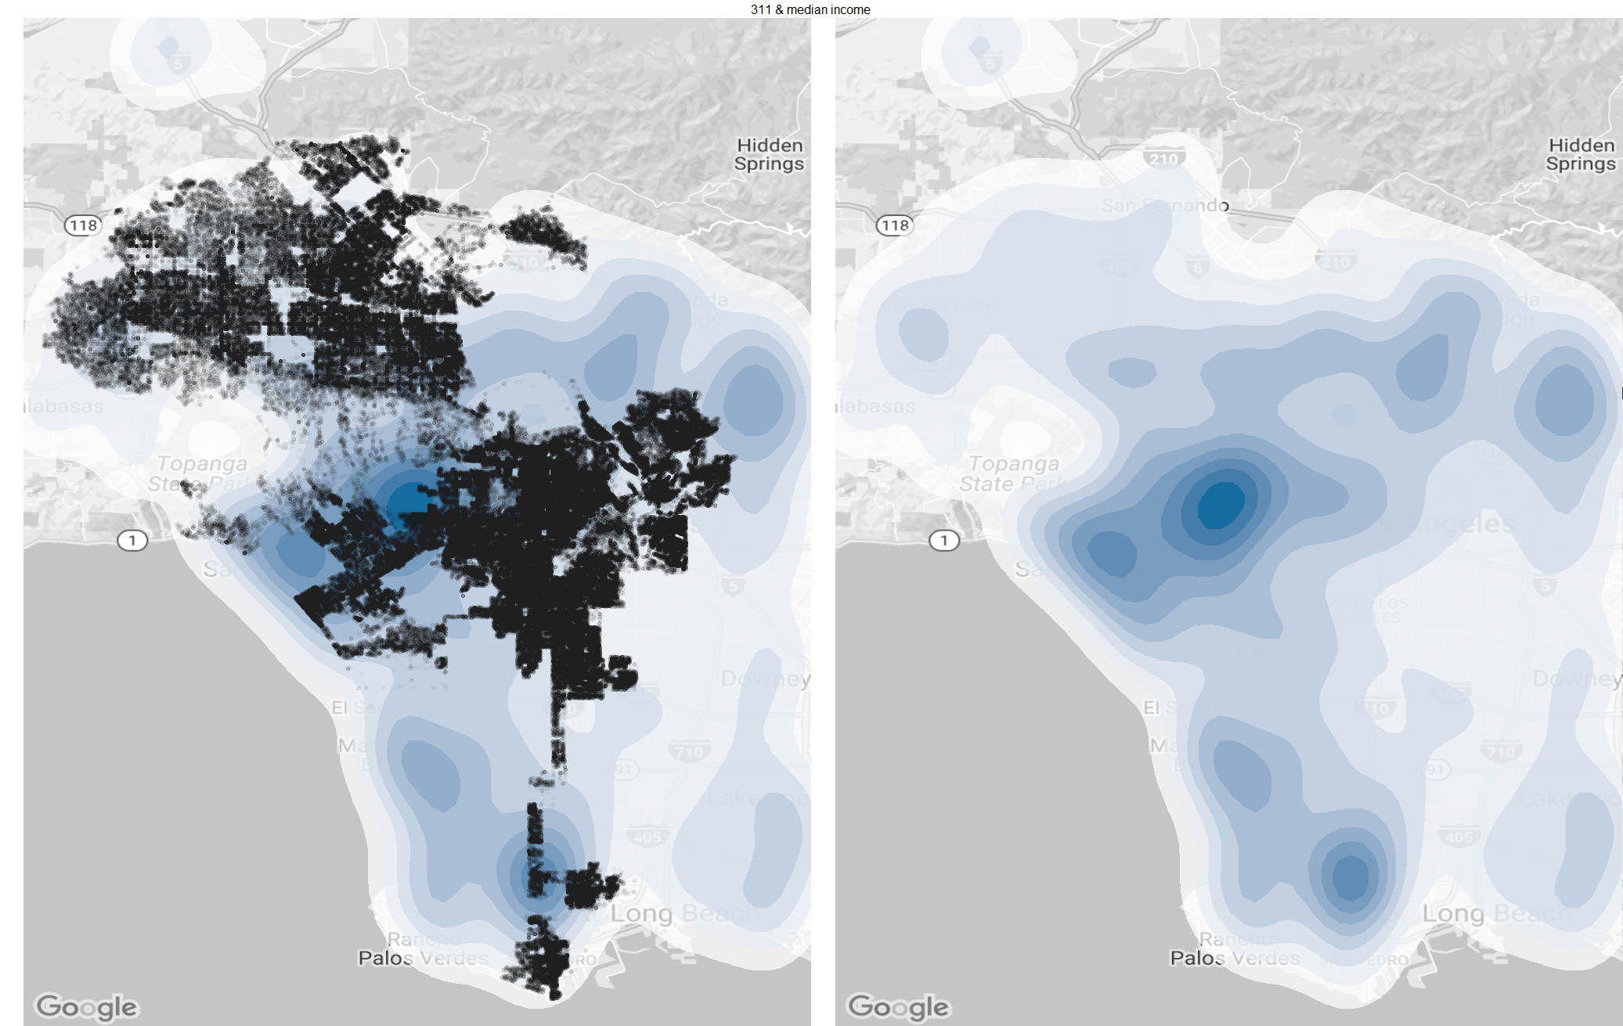

* Pattern found:
* 311 data is generally population related, most requests come from heavy populated area, hollywood, downtown, north hollywooed, santa monica.
* Then we found some lightly populated area displaying as high request frequency as those heavy populated ones, long beach, Malibu, and santa monica beach, so we checked the income map, which turned out that these areas generally enjoy high income level, so it turned out that 311 data is also income related.
* Now we found two areas with high request number, they are neither population related, nor income related, so we recognized them as abnormality.

3.2 Abnormality

* Sunland-Tujunga

This area, although its population is very small and income level is not high, display same pattern as heavy populated area, requesting all sorts of service, from living-related issues, to homeless encampment. So council district 7 could pay more attention to this area.

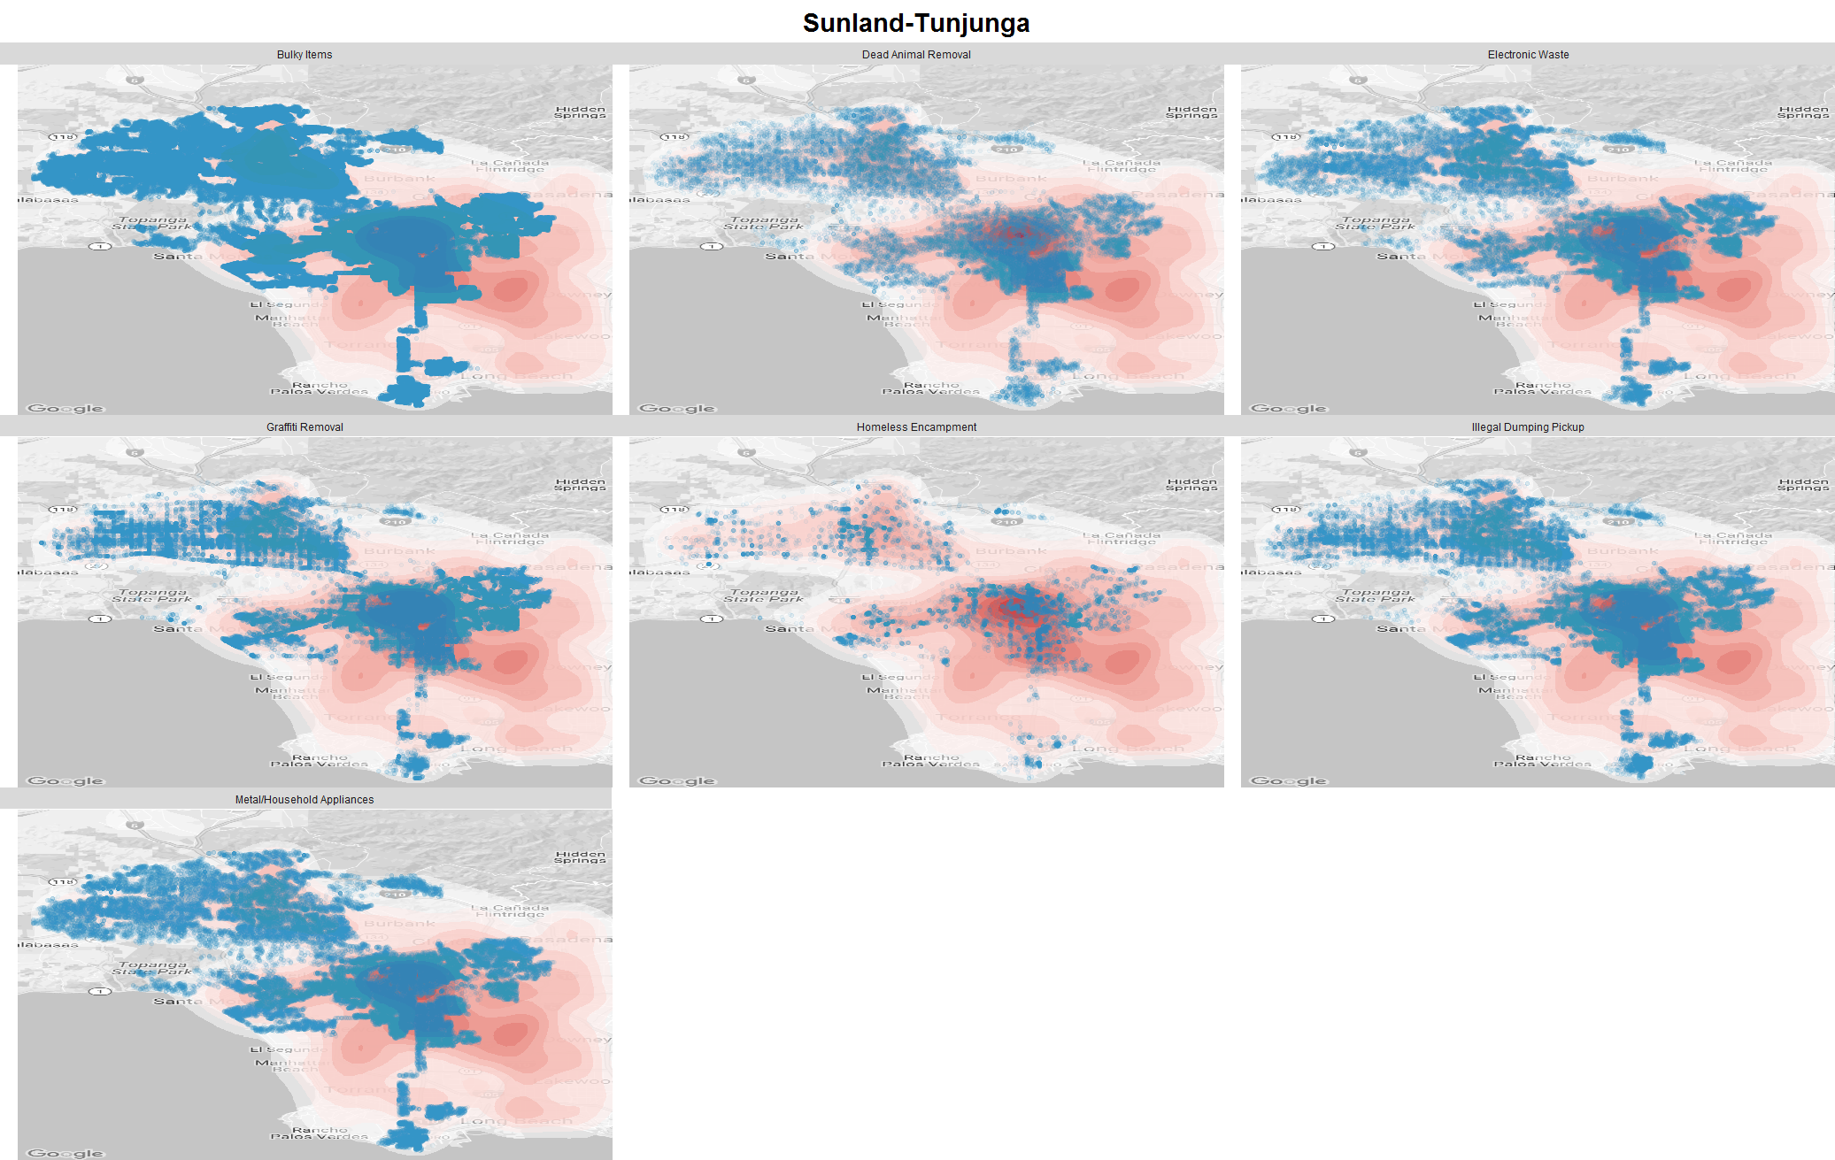

* Airport-Inglewood

This area is also not featured in population or income, but making many requests, especially dead animal removal and streetlight issue, which might be related to airport's location in this area. So, council district 11 should pay more attention to utility improvement in this area.

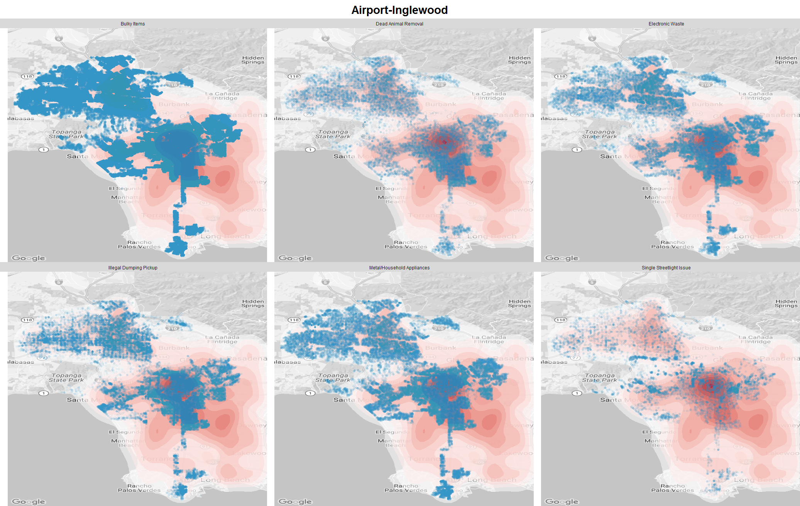

3.3 Identify each area's features

Through breaking down geographic mapping by request type, we could identify the feature of unique areas, and request type.

* Breakdown by request type on population map

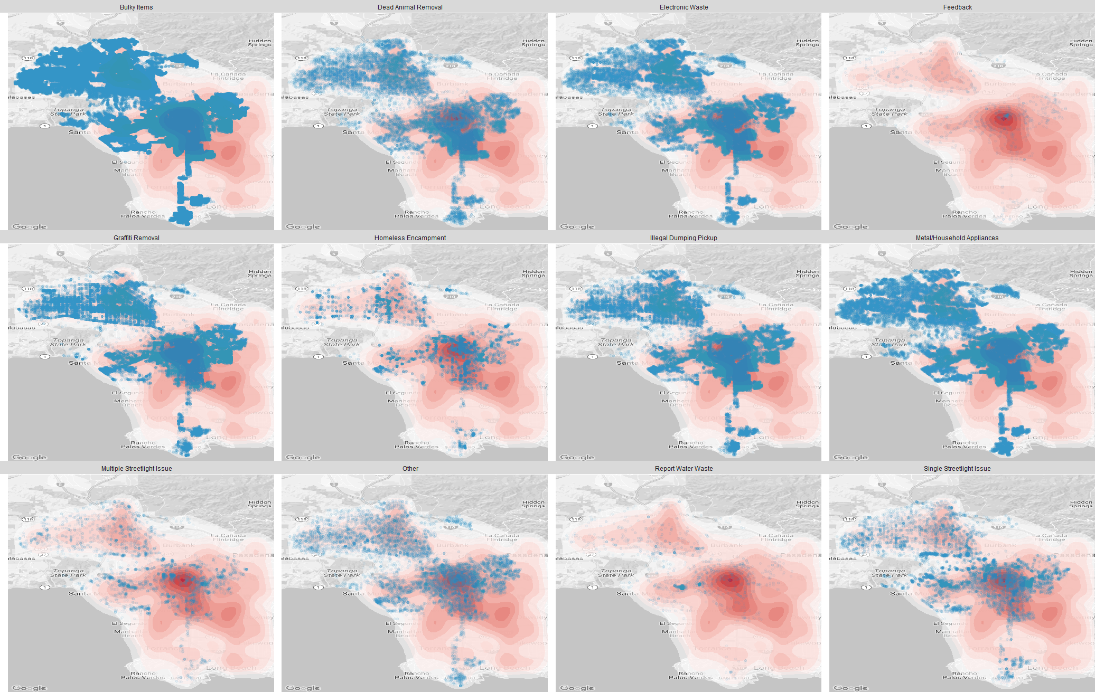

* Breakdown by request type on income map

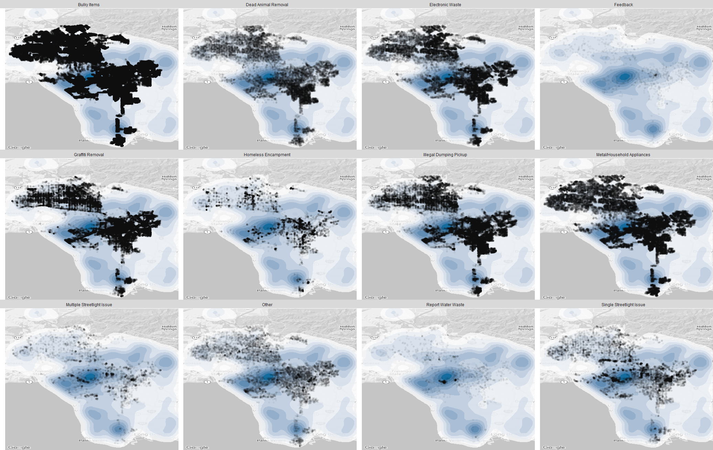

* Breakdown by council district

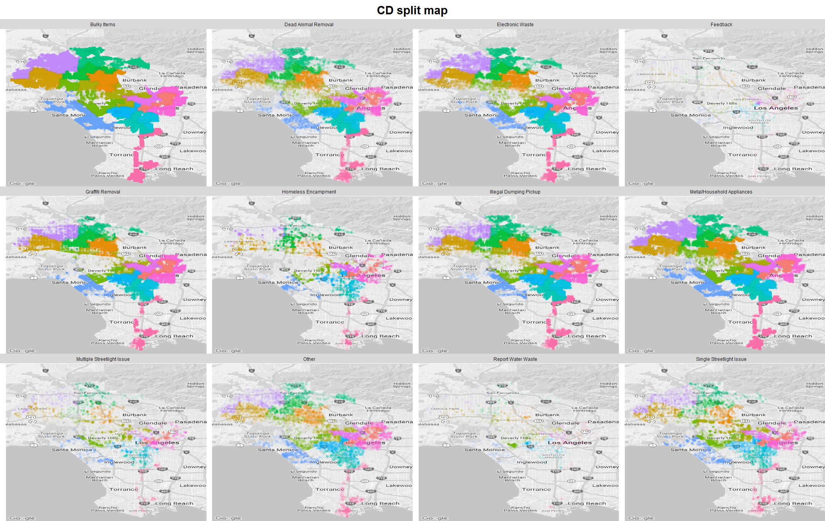

* Feedback is highly population related, centered around hollywood area.

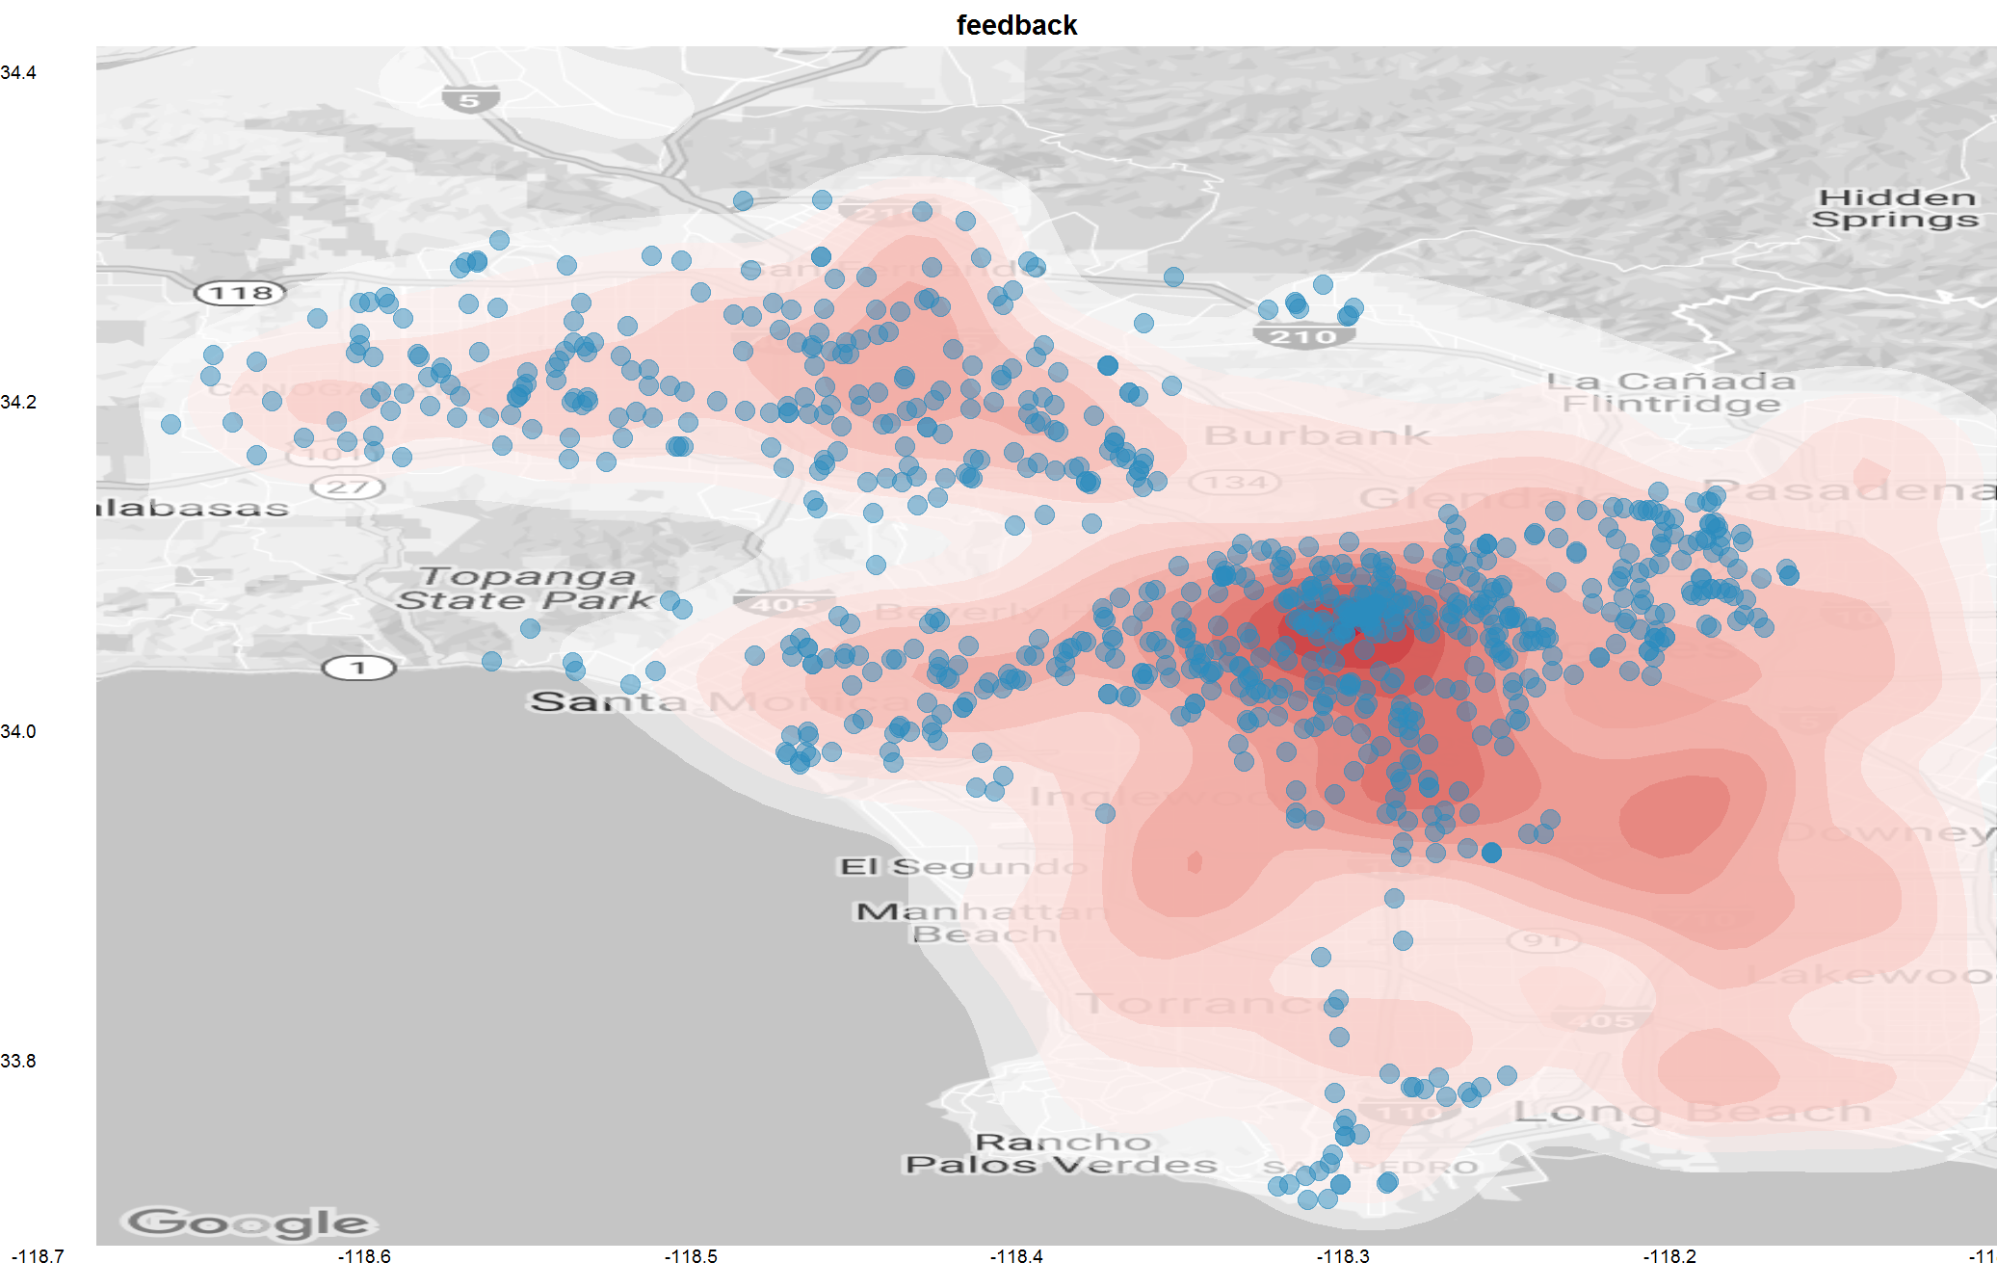

* Water waste is highly income related, centered around west hollywood.

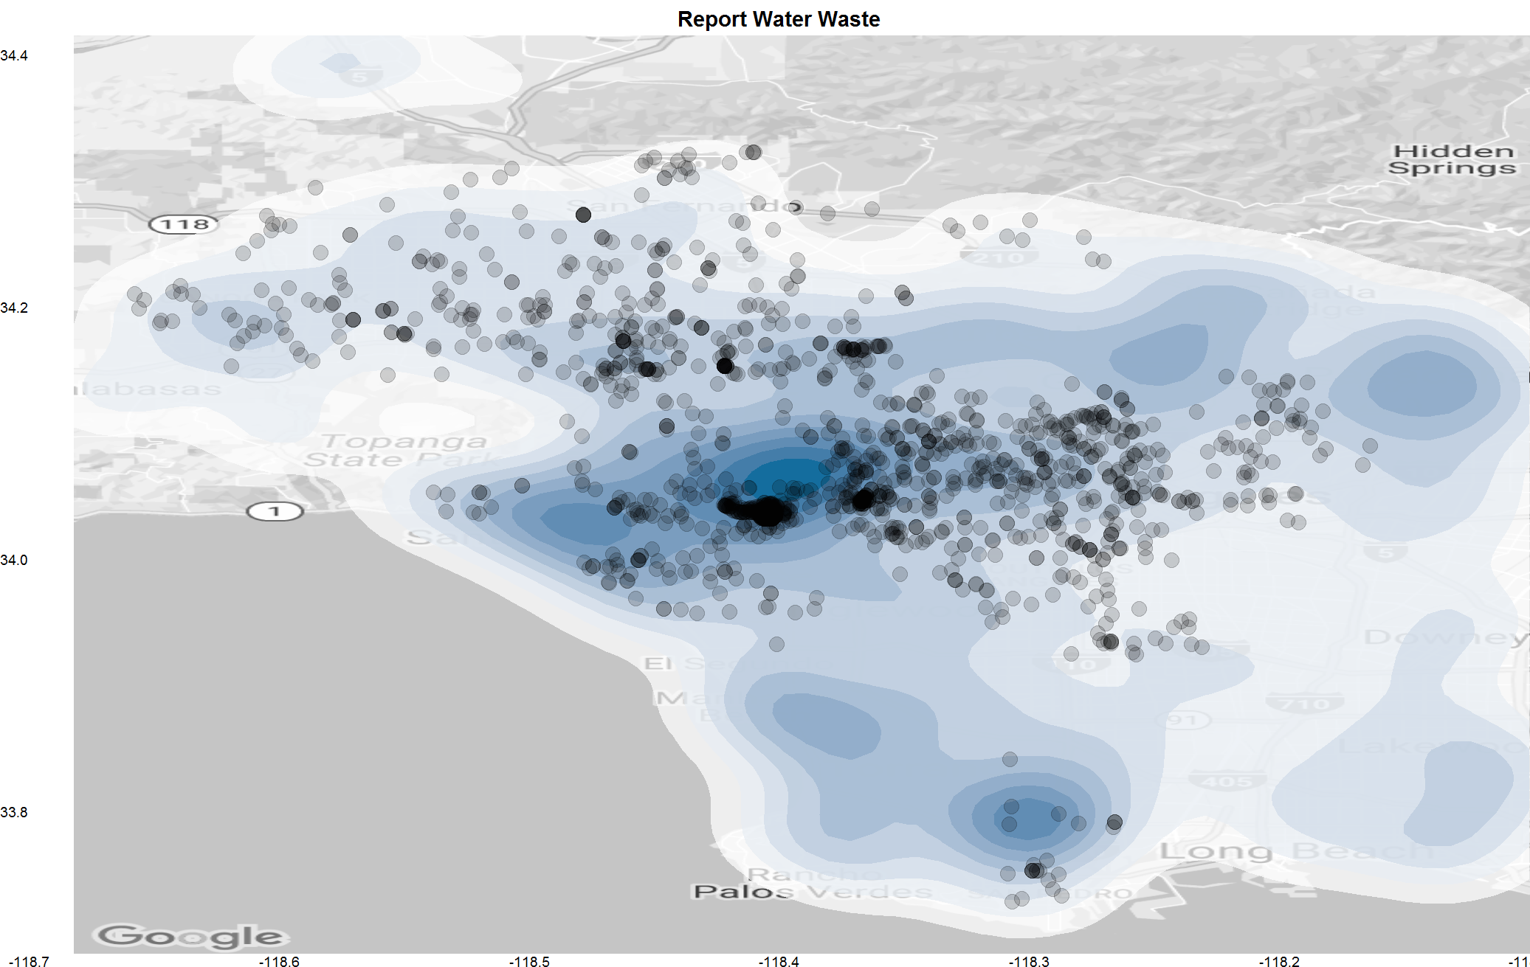

* Abnormal streetlight issue occurs in council district 5, regardless of single or multiple streetlight issue. Council members should look into this.

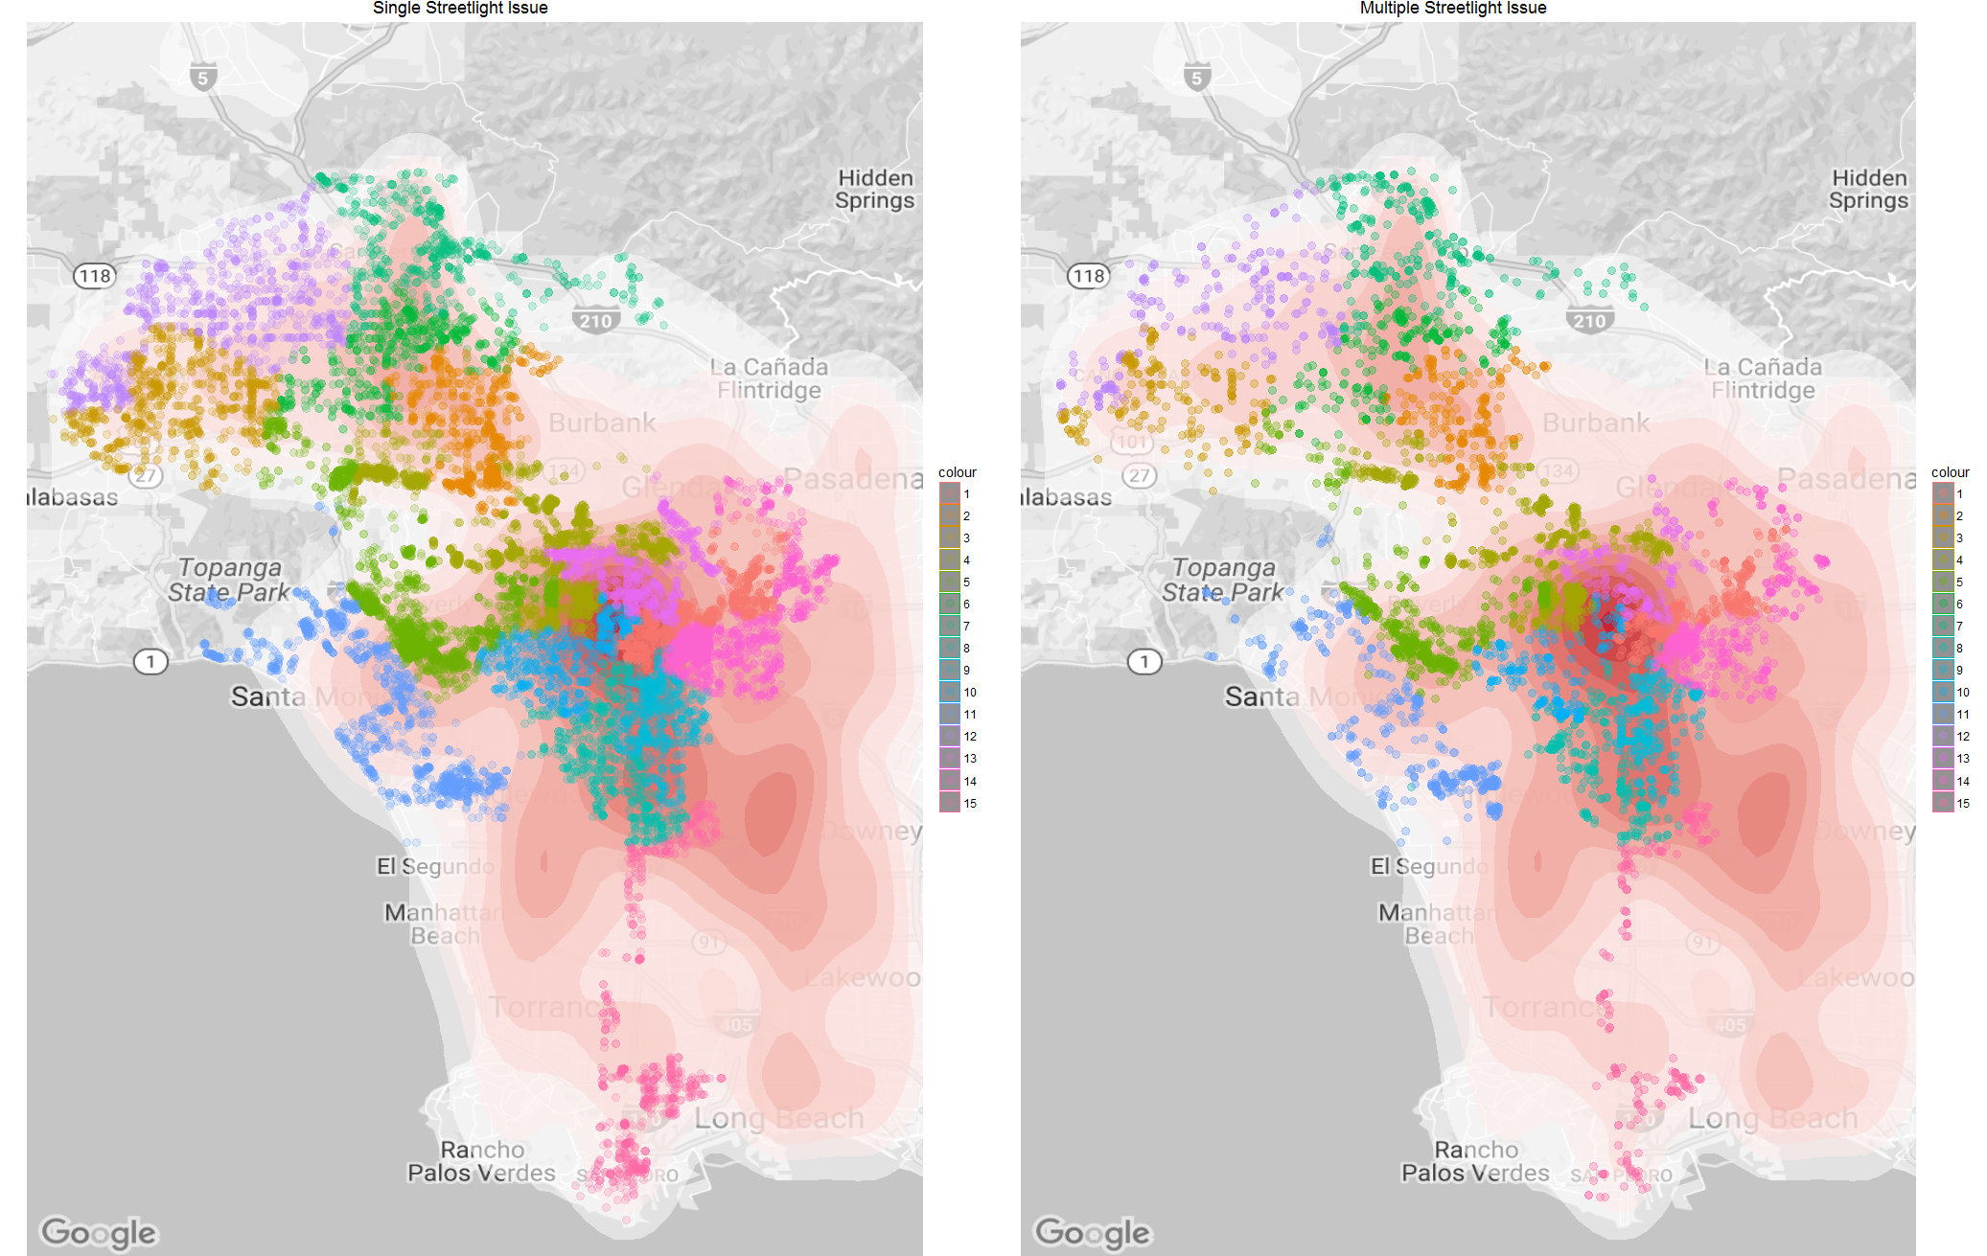

* Malibu, which is lightly populated but as a residential area, it made many requests related to living issues, such as metal/household appliance, electronic waste, and dead animal removal.

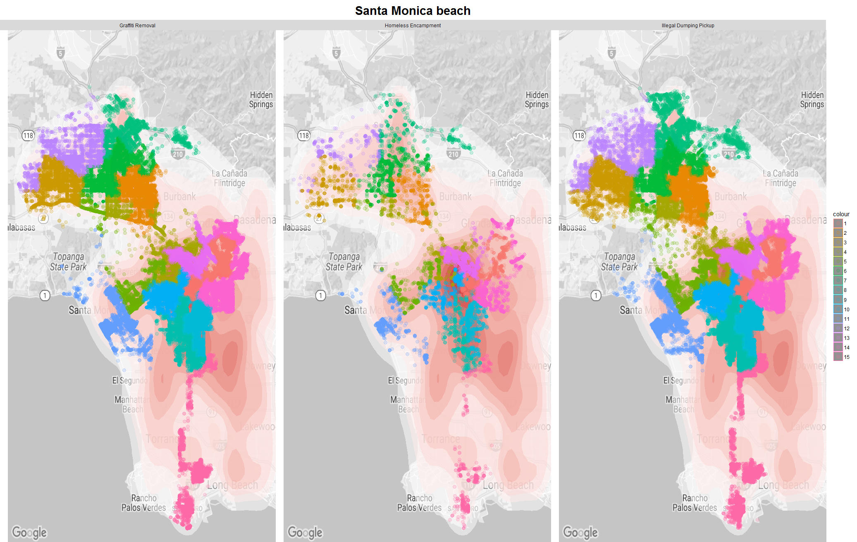

* Santa Monica beach area, which attracts many tourists, made many requests related to public maintenance, such as graffiti, homeless, and illegal dumping.

